There is a board with M\*N size.

The board contains M\*N blocks of 1\*1 size.

Each block is printed a number on it.

You will be given a number, your task is to find whether the number is printed on

any of the blocks or not. If found print true, otherwise print false.

NOTE:

- The numbers printed on the board in each row and each column are

in increasing order. And all the numbers are unique.

Input Format:

-------------

Line-1 -> Two integers M and N, board size.

Next M lines -> N space separated integers.

Last Line -> An integer T, number to search.

Output Format:

--------------

Print a boolean value, 'true' if number found.

otherwise, 'false'.

Sample Input-1:

---------------

4 4

1 3 6 10

2 5 9 13

4 8 12 16

7 11 14 17

5

Sample Output-1:

----------------

true

Sample Input-2:

---------------

4 4

1 3 6 10

2 5 9 13

4 8 12 16

7 11 14 17

15

Sample Output-2:

----------------

False

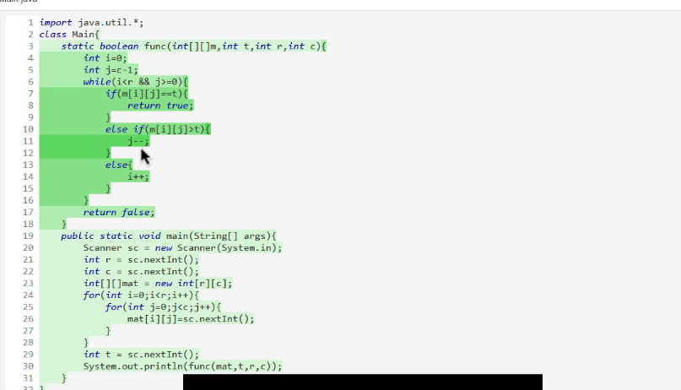

A string is called well-weighted string,if and only if

the string has equal number of 'A's and 'B's in it.

You are given a string S, divide S in to the maximum number of well-weighted strings.

You should not leave any letter/part of the string.

Return the maximum number of well-weighted strings.

Input Format:

-------------

A string contains only A's and B's

Output Format:

--------------

Print an integer, maximum number of well-weighted strings

Sample Input-1:

---------------

ABBBBAAABA

Sample Output-1:

----------------

3

Explanation:

--------------

Well weighted strings, AB, BBBAAA, BA.

Sample Input-2:

---------------

ABAABBABAB

Sample Output-2:

----------------

4

Explanation:

--------------

Well weighted strings, AB, AABB, AB, AB.

Sample Input-3:

---------------

ABAAABBABB

Sample Output-3:

----------------

2

There is a board with M\*N size.

The board contains M\*N blocks of 1\*1 size.

Each block is printed a number on it.

You will be given a number, your task is to find whether the number is printed on

any of the blocks or not. If found print true, otherwise print false.

NOTE:

- The numbers printed on the board in each row are in increasing order.

- Next row starting number is greater than the last number of the previous row.

Constarint:

-----------

Can you solve it in log(M)+ log(N) time.

Input Format:

-------------

Line-1 -> Two integers M and N, board size.

Next M lines -> N space separated integers.

Last Line -> An integer T, number to search.

Output Format:

--------------

Print a boolean value, 'true' if number found.

otherwise, 'false'.

Sample Input-1:

---------------

4 4

1 3 6 10

12 15 19 23

24 28 32 36

37 41 44 47

15

Sample Output-1:

----------------

true

Sample Input-2:

---------------

4 4

1 3 6 10

12 15 19 23

24 28 32 36

37 41 44 47

26

Sample Output-2:

----------------

false

